**Accounts Payable Automation**

**Technical Requirements v.1**



Nexelus USA  
New York, NEW YORK (NY)  
646-558-1950

January 14, 2020

1. Introduction 3

2. System Requirements, Scope, Assumptions 4

3. System Data Flow Design 5

4. Database Design 6

5. User Menu 9

6. Company Configuration 10

7. Routing Setup 11

8. Payment Terms Mapping/Currencies Mapping 13

9. Manage Non-Mapped Invoices 14

10. Manage Invoice Models 16

11. New Invoice Model Setup 17

12. New Invoice Model Setup (Test) 26

13. Invoice Model Setup - Request_<N> 28

14. Manage Invoice Documents 30

15. Review Invoice Document 32

16. Additional Documents 33

# Introduction

AP Automation system will utilize Amazon Textract text detection and analysis API to recognize and identify specific AP Invoice elements that are at interest to AP Automation system. AP Automation system background process (AP Invoice Scanner – APIS process) running at predefined intervals of time (e.g. once an hour) will scan preconfigured client directory that is setup in advance to collect initially all client AP invoices. The results of scanning are fall into two broad categories:

* Recognized (mapped) AP Invoice documents
* Unrecognized (non-mapped) AP Invoice documents

Recognized AP Invoices can be further classified as follows (in order of “flawlessness”):

* Verified Successfully. All the conditions below are satisfied:
* Invoice vendor name (vendor identifier text elements) is found, recognized and mapped to one of the predefined Invoice Models and successfully mapped to ERP Vendor/Vendor Site combination
* All the required AP Invoice elements (Vendor Name, Vendor Invoice Number, Invoice Date, Due Date, Payment Term, Service Term (Start/End Dates), Currency, IO/PO Number(s), IO/PO Net Amount(s) are found on a scanned document
* IO/PO(s) are found for this vendor in integrated AP system these IO(s) are not closed (completed or ended)
* IO/PO Invoice amount(s) are less than IO/PO amount less already delivered amount
* Payment Term and Currency are found in the ERP system applying configured maps between ERP and AP Automation systems, Service Term is correctly verified.
* Verified with Errors. All the conditions below are satisfied:
* Invoice vendor name (vendor identifier text elements) is found, recognized and mapped to one of the predefined Invoice Models and successfully mapped to ERP Vendor/Vendor Site combination
* All the required AP Invoice elements (Vendor Name, Vendor Invoice Number, Invoice Date, Due Date, Payment Term, Service Term (Start/End Dates), Currency, IO/PO Number(s), IO/PO Net Amount(s) are found on a scanned document
* Missing Info. All the conditions below are satisfied:
* Invoice vendor name (vendor identifier text elements) is found, recognized and mapped to one of the predefined Invoice Models and successfully mapped to ERP Vendor/Vendor Site combination
* Some of required AP Invoice elements (Vendor Name, Vendor Invoice Number, Invoice Date, Due Date, Payment Term, Service Term (Start/End Dates), Currency, IO/PO Number(s), IO/PO Net Amount(s) are found on a scanned document
* Missing Vendor Assignment. All the conditions below are satisfied:
* Invoice vendor name (vendor identifier text elements) is found, recognized and mapped to one of the predefined Invoice Models (apam_master_document_model) but ERP Vendor/Vendor Site combination is not assigned for this model - mapping is not entered yet in this client’s model table (apam_document_model table)
* Some of required AP Invoice elements (Vendor Name, Vendor Invoice Number, Invoice Date, Due Date, Payment Term, Service Term (Start/End Dates), Currency, IO/PO Number(s), IO/PO Net Amount(s) are found on a scanned document

These recognized AP Invoices will be listed on AP Invoices -> Manage Invoice Documents screen (see below) where user depending on the status of the AP Invoice can either manually enter missing information, correct errors or review invoice and route for approval.

Unrecognized AP Invoices and Recognized AP Invoices with Missing Vendor Assignment are as such that vendor name on an invoice (vendor identifier text elements) could not be successfully mapped to any one of the predefined Invoice Models or it mapped successfully but generic Invoice Model (from common database) has never been used and never been mapped to Vendor/Site combination . These AP Invoice documents will be listed on AP Invoices -> Manage Non-Mapped Invoices screen (see below) where user can decide what to do with them further – either requesting new mapping (request for creating new Invoice Model), assign vendor/site, route for manual processing or remove as an erroneous file.

# System Requirements, Scope, Assumptions

AP Automation System will be released in two phases: Phase I and Phase II. Phase I will not contain Registration, Trial Accounts, Licensing, Subscription and Billing setup screens. All these elements will be maintained by Nexelus personnel on database level.

Invoice input documents (scanned images or generated) are supported only in PDF, JPEG or PNG formats. AP Automation system will not convert input files from other formats.

Phase I assumes that IO/PO number must be delivered on invoice document and if it is not found, invoice document is considered to have ‘missing info’. Phase II will provide an intelligence to extract IO/PO number from Invoice detail lines description, recognize it and map it to ERP system Campaign/Media Plan to obtain missing IO/PO number.

AP Automation System is designed as totally disconnected, self-sufficient application and does not require any real-time interface to the other system(s). However, AP Automation heavily relies on the data provided by client’s ERP system such as employees, vendor/sites, IO entries, delivery transactional data and organizational position categories to properly function. Thus, AP Automation System will be integrated with ERP system using ERP System API to periodically, on a scheduling basis, fetch required data elements from ERP system. Automatic setup and configuration of ERP system API to feed and update AP Automation tables is not part of Phase I deliverables. It is assumed that Nexelus personnel will configure scheduled procedures to feed AP Automation integration tables with all required data in Phase I. Phase II will use Celigo or MuleSoft API integration platforms to automate data feeds into AP Automation system.

Phase I assumes integration with Nexelus ERP system. Phase II will allow integration with other ERP systems of client’s choice.

AP Automation system needs to deliver (post) processed AP Invoices into ERP system. Phase I will push all processed and approved invoice records into AP Automation system AP Posted Invoices table and Nexelus personnel will configure procedures to fetch these posted AP Invoices on a periodic basis and push it into ERP System tables. Phase II will provide formal AP Automation System API that can be used by any integrated ERP system to fetch processed and approved AP invoices.

AP Automation database design will utilize multi-tenant database approach using Amazon Aurora MySQL database engine initially deployed on a single database instance. Common schema to maintain sharable set of model definitions and corresponding reference data will be reused across client’s dedicated schemas. Each client schema will maintain client setup information, routing setup data, processed invoices, etc.

# System Data Flow Design

Below is high level diagram that shows overall data flow within an application.

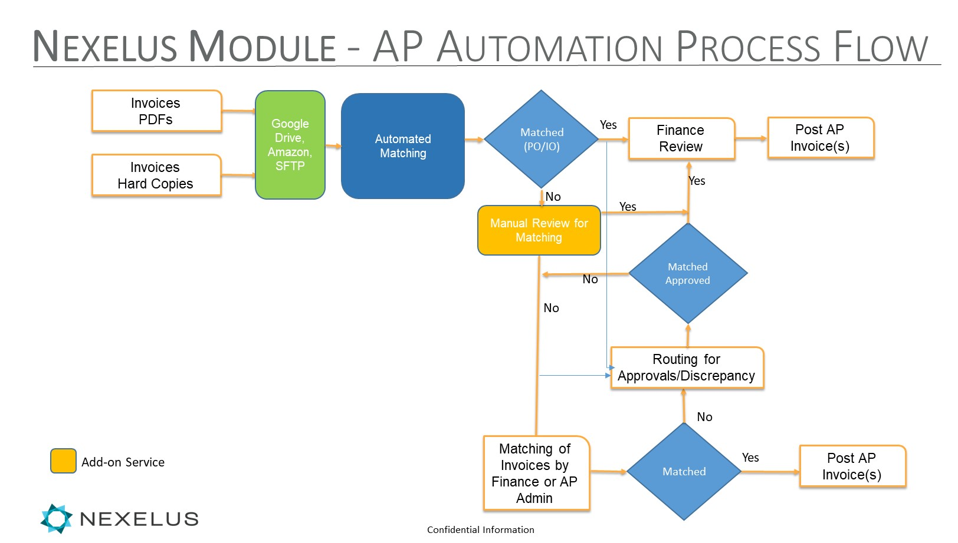

Initially, all client invoices will be accumulated into single dedicated client directory. Automated Matching Process (AP Invoice Scanner – APIS) will periodically scan this directory to process each invoice document. After successful processing invoice document will be archived into another directory within S3 storage and AP Invoice record will be posted to ERP system.

Below is a diagram describing Matching Process.

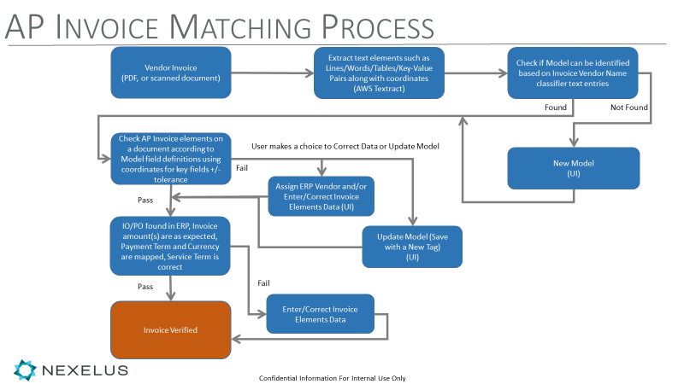

The purpose of invoice matching process is to find appropriate Invoice Model with mapped ERP Vendor/Site and extract all necessary invoice data elements to be able to generate invoice record which can be further routed through approval process and finally posted to ERP System without errors and/or missing information.

# Database Design

Tables are designed and seed data entered in Aurora MySQL database auroratest.cluster-caridxswhlir.us-east-1.rds.amazonaws.com server. Two schemas are designed:

* apautomation_common – sharable schema across multiple clients
* apautomation_360i – individual client schema

Below is 2 ERD diagram for common database and company database. See Additional Documents section for details.

Common Database ERD

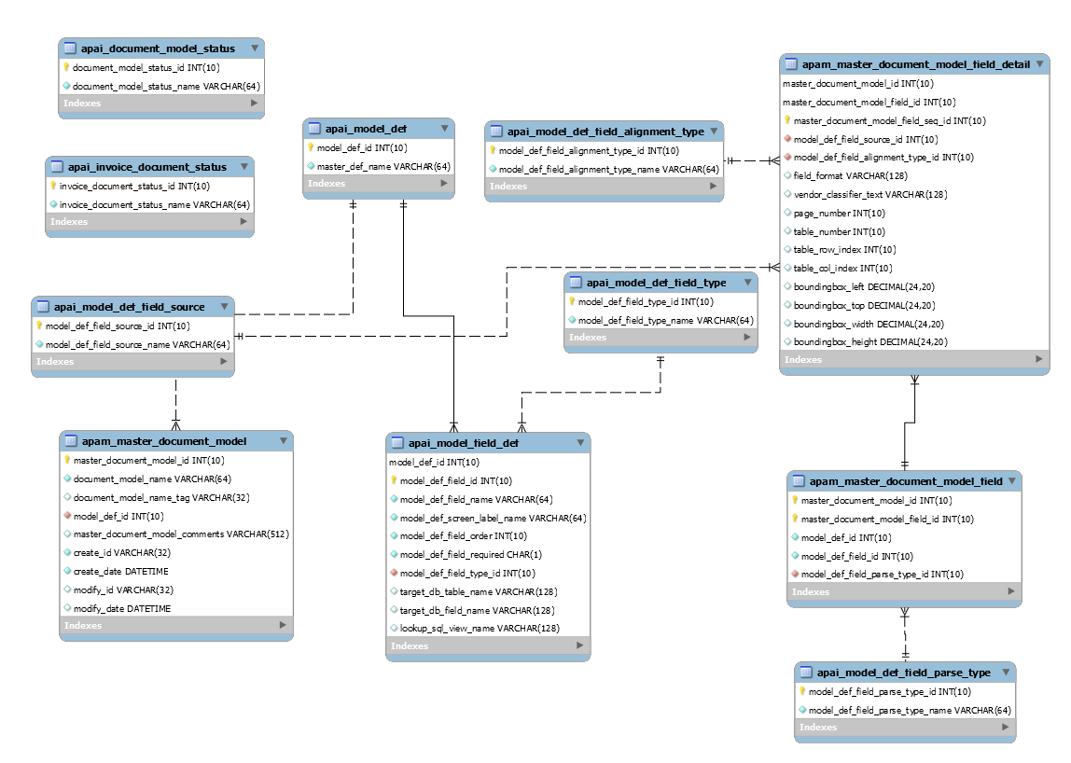

Company database ERD

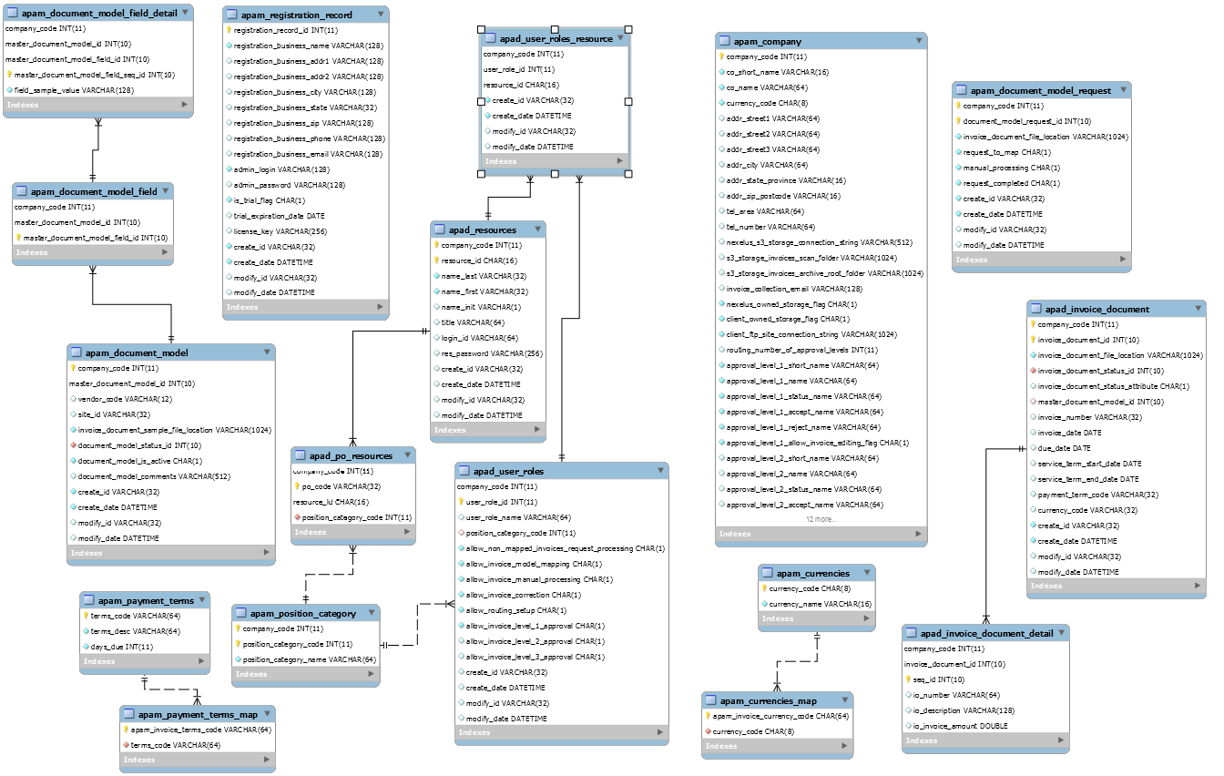

# User Menu

Floating User Menu will be located on the left side of the screen. The same design, colors scheme, style and navigation flow should be used as in NEXELUS application.

System Setup

Company Configuration

Routing Setup

Payment Terms Mapping

Currencies Mapping

AP Invoices

Manage Non-Mapped Invoices

Manage Invoice Models

Manage Invoice Documents

# Company Configuration

This screen lists all the fields from apam_company table. Only AP Automation application admin user is allowed to access this screen in full edit mode. No add/delete record needed. The system always contains single record in this table.

|  |
| --- |
| AP Automation John Doe |

|  |
| --- |
| Company Configuration  The following fields are read-only (fetched from ERP system):   * Company_code * Co_short_name * Co_name * Currency_code * Addr_street1 * Addr_street2 * Addr_street3 * Addr_city * Addr_state_province * Addr_zip_postcode * Tel_area * Tel_number   Depending of number of routing_number_of_approval_levels entered by user (1, 2 or 3 only) set of approval_level_<N>… field will be displayed |

# Routing Setup

This screen is a selection screen from apad_user_roles table. Along with the next screen it allows to maintain user roles introduced in the system. This is so called Routing Setup functionality which allows users to “route” invoice (request for model mapping, manual processing, vendor assignment, editing, approvals, etc.) to the next processing step before getting posted to ERP integrated system.

Position Category Code is an interesting field here… It maps (through lookup) to ERP system position category list through apam_position_category imported from ERP table and provides automatic users assignment to the operations allowed with AP Invoices. Mapping is established between IO/PO numbers recognized on invoices and apad_po_resources imported from ERP table (query based). Essentially, apad_po_resources table contains link between resource_id and IO number through linked Level2/Level3 resources list to PO record.

|  |
| --- |
| AP Automation John Doe |

|  |  |  |  |  |  |  |  |  |  |  |  |  |  |  |  |  |  |  |  |
| --- | --- | --- | --- | --- | --- | --- | --- | --- | --- | --- | --- | --- | --- | --- | --- | --- | --- | --- | --- |
| Routing Setup **New Role**  Search   |  |  |  | | --- | --- | --- | |  | Search: |  |  |  |  |  |  | | --- | --- | --- | --- | | User Role ID | User Role Name | Position Cat Code | Number of Active Users | | 1 | Finance-Admin | Finance | 3 | | 2 | Customer Service |  | 10 | | 3 | Media Manager | Media Approver | 20 |   ** Need to be able to accommodate more than 1 position cat code per user role name  ** Also, for phase II we will need the “approval” threshold.  ** Since IO and invoice will be in the same currency, but could there be any MC considerations with reference to the ERP/Nexelus system? Something to think about |

|  |
| --- |
| AP Automation John Doe |

|  |  |  |  |
| --- | --- | --- | --- |
| Mange User Role Routing   |  |  |  | | --- | --- | --- | | User Role Properties | Users List |  |   Allows editing all the fields from apad_user_roles table.  allow_invoice_level_1_approval always shown (check box)  allow_invoice_level_2_approval and allow_invoice_level_2_approval shown only if Number of Approval levels on a Company Setup is set to 2 or 3. |

|  |
| --- |
| AP Automation John Doe |

|  |  |  |  |
| --- | --- | --- | --- |
| Mange Users List for the Role   |  |  |  | | --- | --- | --- | | User Role Properties | Users List |  |   Allows adding and removing user to the role from apad_resource_table. Results are preserved in apad_user_roles_resource table. |

# Payment Terms Mapping/Currencies Mapping

These mapping screens allow user to establish a map between ERP system Payment Terms and Currencies and AP Automation system Payment Terms and Currencies. AP Automation system Payment Terms map and Currencies map (maintained in apam_payment_terms_map and apam_currencies_map tables) contain entries (apam_invoice_terms_code and apam_invoice_currency_code) that have been found on invoices across the board and they have been added to these map tables in order to map them to ERP system currency_code and payment_term_code values.

# Manage Non-Mapped Invoices

This screen is invoked when user clicks on AP Invoices -> Manage Non-Mapped Invoices.

All the invoice documents are initially collected into predefined directory (Scanned Folder) on Amazon S3 storage. The way how invoice documents get there is configured on Company Configuration screen. In order to avoid name clashes, the original file name will be augmented to include GUID at the end of the name, right before file extension, e.g. Invoice123_<GUID>.pdf. When file name needs to be displayed on the screen, GUID will be stripped and if original file name already exists, it will be appended with (N) where N=1,2,3… to distinguish them on the screen.

When APIS process finds a model with matching vendor name classifier in apam_master_document_model table and no corresponding record exist in apam_document_model table, the record will be inserted automatically into apam_document_model table and invoice_document_sample_file_location field will be populated with the file name. document_model_status_id will be populated with either Not Mapped status if no single invoice attribute found on an invoice, Incomplete Mapping or Fully Mapped depending if all the attributes or some invoice attributes are mapped.

This screen lists all the invoices that APIS process could not recognize (Vendor Name Classifier did not match any model in apam_master_document_model table) as well as recognized invoices but with ERP Vendor/Site missing. The latter can happen when apam_master_document_model record is found based on the Vendor Name Classifier match results but no corresponding record found in apam_document_model table. The screen displays all the files within Scanned Folder except the files that exist in apam_document_model where invoice_document_sample_file_location is populated with this file name and vendor_code/site_id is populated as well.

Search button filters file names in Scanned Folder. Submit button generates records in apam_document_model_request table. document_model_request_id is automatically generated per company_code. request_to_map and manual_processing are Y/N columns depending on checkboxes set on the screen for the given file name. Remove checkbox simply removes a file from the Scanned Folder, no record in apam_document_model_request is generated. request_completed is set to N.

|  |
| --- |
| AP Automation John Doe |

|  |  |  |  |  |  |  |  |  |  |  |  |  |  |  |  |  |  |  |  |  |  |  |  |  |  |  |  |  |  |  |
| --- | --- | --- | --- | --- | --- | --- | --- | --- | --- | --- | --- | --- | --- | --- | --- | --- | --- | --- | --- | --- | --- | --- | --- | --- | --- | --- | --- | --- | --- | --- |
| Manage Non-Mapped Invoices   |  |  |  | | --- | --- | --- | |  | Scanned Folder: | /S3/360I/Staged_AP_Invoices |   Search   |  |  |  | | --- | --- | --- | |  | Search: |  |  |  |  |  |  |  |  | | --- | --- | --- | --- | --- | --- | | File Name | Timestamp | View Invoice | Request for Mapping and/or Vendor Assignment | Route for Manual Processing | Remove | | 5678.pdf | 2020-01-03 4:15:45 PM | View | [X] | [ ] | [ ] | | Foo_3355_1.jpg | 2020-01-03 2:45:03 PM | View | [ ] | [X] | [ ] | | 360i_10121772_Dec_2019_Twitter_Invoice.pdf | 2020-01-03 6:01:03 AM | View | [X] | [ ] | [ ] |   Submit |

# Manage Invoice Models

The screen below lists all the models as defined in apam_master_document_model, apam_document_model and apam_document_model_request tables. Active column can be clicked to toggle Active and not Active mapped to vendor/site models. Switching Active flag to Yes allows model to be used for parsing by APIS process and to No to hold processing for this model. Only models that have ERP Vendor/Site assigned can be set as Active. Not all the models from apam_master_document_model will be shown on this screen. Only models that have corresponding record in apam_document_model table are shown. Also, apam_document_model_request records with request_completed=N are displayed. If record exists in in apam_master_document_model, apam_document_model and apam_document_model_request with the same file name in apam_document_model and apam_document_model_request tables and request_completed=N, that means the invoice model is recognized using Invoice Name Classifier text - Request 2 (abc.pdf) example – and Vendor/Site Id mapping needs to be assigned. When invoice not recognized (no model match) then New model needs to be created.

Model definition cannot be updated under the same Model Name/Tag combination if at least one invoice record exists for this model in apad_invoice_document table (apad_invoice_document. master_document_model_id) – that means at least one invoice has been processed using this model and update is not allowed. However, user can introduce new Tag with the same Model Name. Tag is equivalent to Model version here.

When you say if “at least one invoice has been processed using the model” in the context of not being able to edit, I am assuming that it is centralized so it is across all companies (ad agencies) using this product?

View action allows to view invoice document on the left and model on the right for the invoice that has been used to create model.

All the actions View, Edit, Copy, New, Assign Vendor and Reassign Vendor as well as New button will redirect user to Invoice Model Setup Screen (see New Invoice Model Setup section for details).

|  |
| --- |
| AP Automation John Doe |

|  |  |  |  |  |  |  |  |  |  |  |  |  |  |  |  |  |  |  |  |  |  |  |  |  |  |  |  |  |  |  |  |  |  |  |  |  |  |  |  |  |  |  |  |  |  |  |  |  |  |  |  |  |  |  |  |  |  |  |  |  |  |  |  |  |  |  |  |  |  |  |  |  |  |  |  |  |  |
| --- | --- | --- | --- | --- | --- | --- | --- | --- | --- | --- | --- | --- | --- | --- | --- | --- | --- | --- | --- | --- | --- | --- | --- | --- | --- | --- | --- | --- | --- | --- | --- | --- | --- | --- | --- | --- | --- | --- | --- | --- | --- | --- | --- | --- | --- | --- | --- | --- | --- | --- | --- | --- | --- | --- | --- | --- | --- | --- | --- | --- | --- | --- | --- | --- | --- | --- | --- | --- | --- | --- | --- | --- | --- | --- | --- | --- | --- |
| Manage Invoice Models  Search   |  |  |  | | --- | --- | --- | |  | Search: |  |  |  |  | | --- | --- | |  | New Model |  |  |  |  |  |  |  |  |  | | --- | --- | --- | --- | --- | --- | --- | --- | | ID | Model Name | Model Tag | Model Status | Active | ERP Vendor | ERP Vendor Site | Actions | | 1 | Facebook | V1 | Fully Mapped | Yes | 10025 – Facebook | 001 | View / Copy | | 2 | Facebook | V2 | Forced Mapped | Yes | 10025 – Facebook | 001 | View / Copy | | 23 | Facebook | V3 | Forced Mapped | No | 10025 – Facebook | 002 | Edit / Copy / Reassign Vendor | | 3 | TradeDesk | V1 | Fully Mapped | No | 1125 – TradeDesk | 001 | Edit / Copy / Reassign Vendor | | 4 | TradeDesk | V2 | Forced Mapped | No | 1125 – TradeDesk | 002 | Edit / Copy / Reassign Vendor | | Request 1 (5678.pdf) |  |  |  |  |  |  | New | | Request 2 (abc.pdf) | 33ACROSS | V1 | Fully Mapped | No |  |  | Edit / Copy / Assign Vendor | | 5 | Twitter | V1 | Incomplete Mapping | No | Twitter | 001 | Edit / Copy / Reassign Vendor | |

# New Invoice Model Setup

As it is written below, for Phase I we will utilizing the mapping “model” of invoice without any prediction on mapping suggestion based on data in the system. But for Phase we will have the ability for the system to suggest a mapping to be approved and edited. In this phase user will literally map fields/text on the invoice to our required fields.

This is the main “core” application screen where mapping between some text elements on parsed invoice document (PDF or image) and AP Invoice attributes is defined by the user. The left side of the screen always reserved for the invoice document, either raw or parsed with overlaying rectangles around parsed lines (Markup – Lines button), words Markup – Words button), key-value pairs (Markup – Key-Value Pairs button) or highlighted table cells if user choose to view invoice with table markup (Markup – Tables button). If user clicks on New Model button on Manage Invoice Model screen (above) then screen will look like a screen below where user can explicitly upload invoice document from the local machine using Upload Invoice Document button. If screen is displayed as result of calling one of the View, Edit, Copy, New, Assign Vendor or Reassign Vendor actions on the previous screen then Model Setup screen will have preloaded already raw invoice from the mapped model or the request and will look similar to the screen described in Invoice Model Setup – Request_<N> section of the current document.

Below are the rules for the right part of the screen for different actions initiated from the Manage Invoice Models screen:

1. New Model – user clicks on New Model button on Manage Invoice Model screen

* Upload Invoice Document button is visible and enabled. This button selects a file from user’s local drive (it could be an option to select a file from client’s /S3 folder where all the invoice documents are dumped), only pdf and jpg file extensions are supported. As long as user selects a file, it is being parsed immediately by Textract API using all four Textract parsing types: Lines, Words, Tables and Key-Pairs and initially Invoice Image is shown on the left, View Raw Invoice option is highlighted, Pages entry is set to the first page (if file is a JPEG image, Pages entry is hidden because image ss always a single page).
* When user clicks on of the four options Markup – Lines, Markup – Words, Markup – Tables, Markup Key-Value Pairs, the left pane becomes outlined with rectangles for words, lines, key-value pairs and for the tables, tables are highlighted and each cell in each table is additionally highlighted when user hoovers mouse over the cell. Then, user can drag the item from the left pane to the right pane invoice elements and drop them there. Additional information is preserved, such as geometry, page_number, table_number, table_row_index, table_col_index if needed.
* There are two outcomes of the file parsing results: document is recognized and it matches to the existing model(s) or it is not recognized – no match to existing model found. If document is recognized then all recognized/matched fields will be populated on the right side of the screen from apam_master_document_model, apam_document_model, apam_master_document_model_field and apam_master_document_model_field_detail tables. The data, however, will be pushed directly from invoice pdf/image for recognized fields.
* Below are criteria and business logic for invoice document recognition or “best matching”:
* First, all the models are scanned to find matching Vendor Classifier entries. Vendor Classifier entries (as any other entry) can be set as Lines, Words, Tables and Key-Pairs type of parsing. If they set as Words or Lines and there is only single entry then text has to match exactly and bounding box values (left, top, width, height) must match (**2% tolerance criteria should be initially set, some R&D needs to be done to identify more precise and appropriate setting. This setting must be global – there is no way to define this setting per model. Same goes for Textract Confidence attribute – only R&D can reveal the proper Confidence threshold**) to the values preserved in apam_master_document_model_field_detail table for field which is defined as AP Invoice model/Vendor Classifier field in apam_master_document_model_field table (model_def_id = 1, model_def_field_id = 1). Also, page_number field must match as well to the parsed value. If type of parsing is Table then text, page_number, table_number, table_row_index and table_col_index must match to the parsed values. Key-Value pairs will not be supported for Vendor Classifier (meaning if user clicks on Markup – Key-Value Pairs button, user will not be able to drag anything from left to Vendor Classifier entries.
* If there are multiple entries for Vendor classifier, then all above has to be verified for each entry. In addition to that, “distance” between entries (top, left corner) has to be checked (2% tolerance is allowed) – see <https://www.calculatorsoup.com/calculators/geometry-plane/distance-two-points.php> for details - this may give better recognition results.
* There are two outcomes for matching (recognition) – match to a single model or multiple models. If match is found for the single model then all other fields are populated according to the model definition (invoice data is extracted directly from the parsed document on the left and overrides sample data from model definition). If there more than a single model match, we have to find “the best” matching model. All other fields have to checked as well (see details below for specifics of each field type) and the model with the most fields matched (geometry tolerance level and confidence level do not need to be taken into account here, i.e. model is not considered “better match” if all geometry data is “closer”/confidence level higher to the parsed invoice on the left in one model than in another model) is considered a best match. Then this model is populated on the screen. If we found two models with the same number of match fields then any model is picked.
* If this model is Active model, it cannot be edited and saved, but different Model Name/Tag can be entered and when user saves this model, new master_document_model_id is generated and new entries will be made in six tables – apam_master_document_model, apam_master_document_model_field, apam_master_document_model_field_detail, apam_document_model, apam_document_model_field, apam_document_model_field_detail.
* Model Properties section on the right pane.
* Model Name is text entry with search capabilities displaying list of apam_master_document_model. document_model_name field values. Search screen may also display vendor_code, site_id, invoice_document_sample_file_location, document_model_status_id/name fields from left join of apam_master_document_model table to apam_document_model. Blank for unrecognized invoice or apam_master_document_model.document_model_name for found matched model.
* Model Tag is a free entry text field. Please note Model Name/Model Tag combination must be unique in apam_master_document_model table. Blank for unrecognized invoice or apam_master_document_model.document_model_name_tag for found matched model.
* Status is blank for unrecognized invoice or apam_document_model.document_model_status_id/name for found matched model.
* Active checkbox is unchecked for unrecognized invoice or apam_document_model.document_model_is_active for found matched model.
* ERP Vendor/ERP Vendor Site is a lookup that should look similar to the Nexelus lookup below

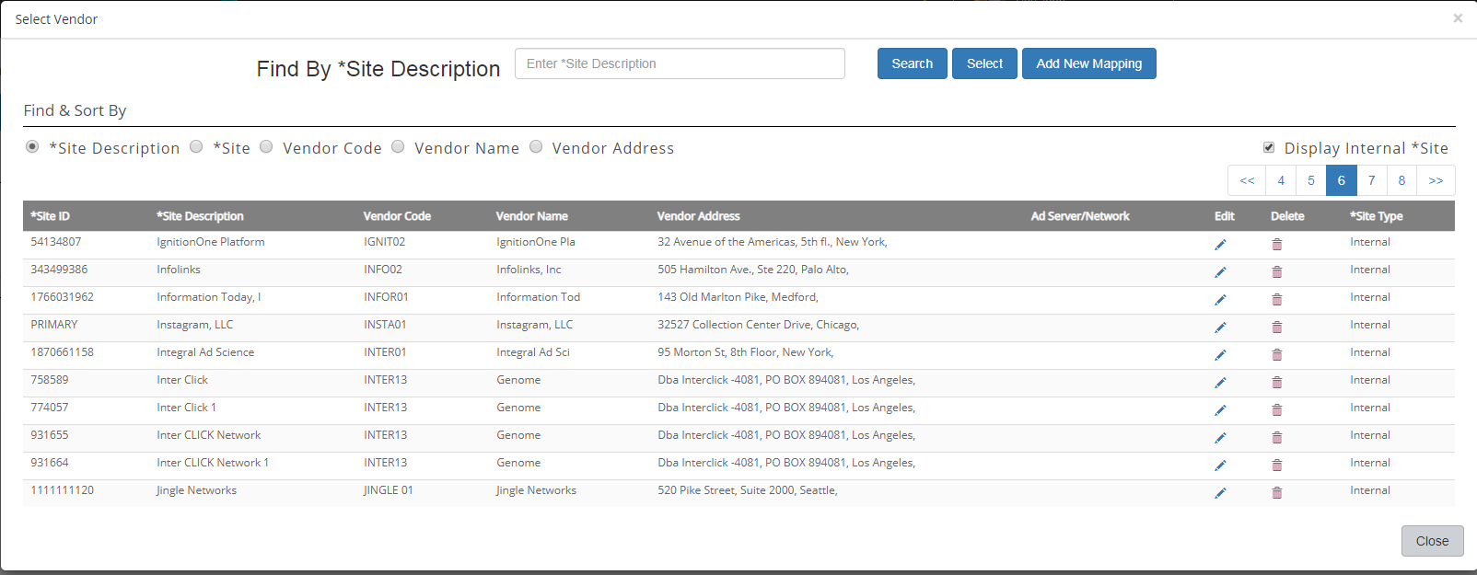

**Tao would be the best person to design APAutomation Vendor/Sites integration table in MySQL database and prepare synchronization routines to fetch and update this table from ERP system.** Blank for unrecognized invoice or apam_document_model.vendor_code/site_id for found matched model.

* Mapped Invoice Fields section on the right pane
* The fields in this section are built dynamically based on the entries in apai_model_field_def table. apai_model_field_def.model_def_field_type_id dictates specifics for each field.
* Vendor Classifier (apai_model_field_def.model_def_field_type_id=10) is initially displayed as a single text box (if invoice is not recognized) or as defined in apam_master_document_model_field and apam_master_document_model_field_detail tables. These text box(es) are not editable and can only accept “drop” of the content from the left pane. For Vendor Classifier user can only drop markups as Lines, Words and Tables. If user switches from Lines to Words, for example but content of Vendor Classifier entries was dropped as Lines, “drop” operation is disabled. User has to start all over again with Vendor Classifier clearing up (deleting) all entries using *Remove All* link. *Remove All* link removes all textboxes and creates single empty box (Keyword 1). + and – buttons to the right allow user add/remove individual entries. apam_master_document_model_field_detail.model_def_field_source_id will be set to 10 for Lines or Words markup and to 50 for table markup.
* Vendor Invoice Number (apai_model_field_def.model_def_field_type_id=20) is set as defined in apam_master_document_model_field and apam_master_document_model_field_detail tables for recognized models. Even for recognized models there could be a case when Vendor Invoice Number is not defined (Forced Mapping or Incomplete) - then single line is displayed in Vendor Invoice Number table with empty Invoice Input, Source set to Label and Alignment set to Left. Below are allowed values for Source depending on Parse Type:

|  |  |
| --- | --- |
| Parse Type | Source |
| Lines | |  | | --- | | Label | | Value | |
| Words | |  | | --- | | Label | | Value | |
| Tables | |  | | --- | | Label-Table-Header | | Value-Table-Header | | Label-Table-Detail | | Value-Table-Detail | | Label-Table-Footer | | Value-Table-Footer | |
| Key-Value Pairs | |  | | --- | | Key-Value-Pair (Single) | | Key-Value-Pair (Multi) | |

Label sources are as such that content defined in apam_master_document_model_field_detail.field_sample_value must match exactly to the parsed invoice field. Elements with Value sources types are actual data like invoice numbers, currency code, invoice date, etc. They have to match to their geometry attributes, table, row/col index, etc. and value cannot be blank. Label-Table-Detail, Value-Table-Detail and Key-Value-Pair (Multi) Source types represent multi-entries such as invoice detail lines with IO Number and IO Amount. These elements will be recognized as follows:

* Tables. Both Label-Table-Detail and Value-Table-Detail must be defined on a right side. Label-Table-Detail and Value-Table-Detail table_col_index must match exactly. Label-Table-Detail must match exactly to the sample text defined for the model (apam_document_model_field_detail.field_sample_value) and the only values that will be taken into consideration are the values that match respective labels across all pages and tables. apam_master_document_model_field_detail.page_number and apam_master_document_model_field_detail.table_number ser set to null.
* Key-Value-Pair (Multi). Key-Value pairs are dropped together as key~value into single line on a right pane field entry. No alignment column displayed if Source is Key-Value-Pair. All the values with the same key and non-blank value from the whole invoice across all pages will be taken into consideration. […] denotes on the screen that there are multiple values parsed and user can view them clicking on this.

If Parse Type are Lines or Words and Source is Value then alignment influences geometry calculations. To calculate match, for left alignment, only top, left, bottom coordinates have to be used and for distance calculations top, left have to be used. For right alignment, only top, right, bottom coordinates have to be used and for distance calculations top, right have to be used. For center alignments, top, (right-left)/2, bottom have to be used and for distance calculations top, (right-left)/2 have to be used.

* Vendor Invoice Date and Due Date (apai_model_field_def.model_def_field_type_id=30). In addition to the Vendor Invoice Number functionality date format is added – this is free entry text but it’s validated against using only DD DDD D YY YYYY MM MMM strings with / <space>, <comma> and – (dash) combinations as single delimiter. For example, MM-DD-YYYY, MMDDYYYY and D MMM YYYY are valid but MM—DD-YYYY or MM-DD- YYYY or MMMM-DD-YYYY are not valid.
* Service Term (Start/End Dates) (apai_model_field_def.model_def_field_type_id=40). In addition to the previous fields this range type of fields supports from/to values at the same time. This is controlled using filed format attribute. In addition to Date formats, FULL:, FROM: and TO: prefixes are allowed to denote a date range.
* Payment Term and Currency fields. These are lookup fields. (apai_model_field_def.model_def_field_type_id=50
* IO/PO Number and IO/PO Description. apai_model_field_def.model_def_field_type_id=20.
* IO/PO Net Amount. Numeric field. Validation required for Value source type. apai_model_field_def.model_def_field_type_id=60.
* Mark as completed checkbox. User checks this box to denote that the Model is Forced Mapped, meaning that not all required fields are defined and mapped but model will be used nether the less and invoices matching this model will be parsed with Missing Info status (apad_invoice_document.invoice_document_status_id = 40).
* Save button. When user clicks Save button, six tables – apam_master_document_model, apam_master_document_model_field, apam_master_document_model_field_detail, apam_document_model, apam_document_model_field, apam_document_model_field_detail – will be updated or new records inserted depending on whether entered Model Name/Model Tag combination already exists in apam_master_document_model table or not.

1. New action – user clicks on New action for submitted request.

* In the header, the requested file name full path is displayed, Upload button is hidden, invoice document parsed and loaded on the left. Invoice Models are searched (just in case) and most likely, no model found for this invoice, so all the invoice entries on the left are blank.
* After user maps the model and saves it to 6 database tables (see above), invoice map request marked as Completed only if ERP Vendor/Site is mapped, otherwise Completed flag is still N.
* Invoice document record is updated in apad_invoice_document and record(s) are created in apad_invoice_document_detail table as needed. apad_invoice_document.invoice_document_status_id is set accordingly (Missing Vendor Assignment, Verified Successfully, Verified with Errors or Missing Info)

1. Assign Vendor action – user clicks on Assign Vendor action for submitted request and mapped models. The same screen as in New action is displayed and user assigns Vendor/Site and saves changes under the same Model Name/Tag – these are not editable fields. It’s allowed to make changes to invoice elements if needed.
2. Reassign Vendor action – user clicks on Reassign Vendor action for non-active models. The same screen as in New action is displayed and user reassigns Vendor/Site and saves changes under the same Model Name/Tag – these are not editable fields as well all other invoice elements.
3. Edit action - user clicks on Edit action for non-active models. The same screen as in New action is displayed. The system must check if this model was used for parsing invoices: apad_invoice_document.invoice_document_model_id (samples are excluded – apam_document_model.invoice_document_sample_file_location). If it was used, then user must enter new Model Name/Model Tag combination after making changes to invoice elements.
4. Copy action - user clicks on Copy action. The same screen as in New action is displayed with Model Name/Model Tag prefixed with Copy of text.
5. View action - user clicks on View action. The same screen as in New action is displayed. No editing is allowed. Save button is disabled.

I would like Faisal to look at this site where we had a semi working mock up, I will include some files of invoices to use as a sample

<https://release.nexelus.net/apworkflow/>

|  |
| --- |
| AP Automation John Doe |

|  |  |  |  |  |  |  |  |  |  |  |  |  |  |  |  |  |  |  |  |  |  |  |  |  |  |  |  |  |  |  |  |  |  |  |  |  |  |  |  |  |  |  |  |  |  |  |  |  |  |  |  |  |  |  |  |  |  |  |  |  |  |  |  |  |  |  |  |  |  |  |  |  |  |  |  |  |  |  |  |  |  |  |  |  |  |  |  |  |  |  |  |  |  |  |  |  |  |  |  |  |  |  |  |  |  |  |  |  |  |  |  |  |  |  |  |  |  |  |  |  |  |  |  |  |  |  |  |  |  |  |  |  |  |  |  |  |  |  |  |  |  |  |  |  |  |  |  |  |  |  |  |  |  |  |  |  |  |  |  |  |  |  |  |  |  |  |  |  |  |  |  |  |  |  |  |  |  |  |
| --- | --- | --- | --- | --- | --- | --- | --- | --- | --- | --- | --- | --- | --- | --- | --- | --- | --- | --- | --- | --- | --- | --- | --- | --- | --- | --- | --- | --- | --- | --- | --- | --- | --- | --- | --- | --- | --- | --- | --- | --- | --- | --- | --- | --- | --- | --- | --- | --- | --- | --- | --- | --- | --- | --- | --- | --- | --- | --- | --- | --- | --- | --- | --- | --- | --- | --- | --- | --- | --- | --- | --- | --- | --- | --- | --- | --- | --- | --- | --- | --- | --- | --- | --- | --- | --- | --- | --- | --- | --- | --- | --- | --- | --- | --- | --- | --- | --- | --- | --- | --- | --- | --- | --- | --- | --- | --- | --- | --- | --- | --- | --- | --- | --- | --- | --- | --- | --- | --- | --- | --- | --- | --- | --- | --- | --- | --- | --- | --- | --- | --- | --- | --- | --- | --- | --- | --- | --- | --- | --- | --- | --- | --- | --- | --- | --- | --- | --- | --- | --- | --- | --- | --- | --- | --- | --- | --- | --- | --- | --- | --- | --- | --- | --- | --- | --- | --- | --- | --- | --- | --- | --- | --- | --- | --- | --- | --- | --- | --- |
| New Invoice Model Setup  File Name: TD_123.pdf (uploaded)   |  |  |  |  |  |  |  | | --- | --- | --- | --- | --- | --- | --- | | View Raw Invoice | Markup - Lines | Markup - Words | Markup - Tables | Markup - Key-Value Pairs | Upload Invoice Document |  |      |  |  |  |  |  |  |  |  |  |  |  |  |  |  |  |  |  |  |  |  |  |  |  |  |  |  |  |  |  |  |  |  |  |  |  |  |  |  |  |  |  |  |  |  |  |  |  |  |  |  |  |  |  |  |  |  |  |  |  |  |  |  |  |  |  |  |  |  |  |  |  |  |  |  |  |  |  |  |  |  |  |  |  |  |  |  |  |  |  |  |  |  |  |  |  |  |  |  |  |  |  |  |  |  |  |  |  |  |  |  |  |  |  |  |  |  |  |  |  |  |  |  |  |  |  |  |  |  |  |  |  |  |  |  |  |  |  |  |  |  |  |  |  |  |  |  |  |  |  |  |  |  |  |  |  |  |  |  |  |  |  |  |  |  |  |  |  | | --- | --- | --- | --- | --- | --- | --- | --- | --- | --- | --- | --- | --- | --- | --- | --- | --- | --- | --- | --- | --- | --- | --- | --- | --- | --- | --- | --- | --- | --- | --- | --- | --- | --- | --- | --- | --- | --- | --- | --- | --- | --- | --- | --- | --- | --- | --- | --- | --- | --- | --- | --- | --- | --- | --- | --- | --- | --- | --- | --- | --- | --- | --- | --- | --- | --- | --- | --- | --- | --- | --- | --- | --- | --- | --- | --- | --- | --- | --- | --- | --- | --- | --- | --- | --- | --- | --- | --- | --- | --- | --- | --- | --- | --- | --- | --- | --- | --- | --- | --- | --- | --- | --- | --- | --- | --- | --- | --- | --- | --- | --- | --- | --- | --- | --- | --- | --- | --- | --- | --- | --- | --- | --- | --- | --- | --- | --- | --- | --- | --- | --- | --- | --- | --- | --- | --- | --- | --- | --- | --- | --- | --- | --- | --- | --- | --- | --- | --- | --- | --- | --- | --- | --- | --- | --- | --- | --- | --- | --- | --- | --- | --- | --- | --- | --- | --- | --- | |  | **Model Properties**   |  |  |  | | --- | --- | --- | | Model Name: | Enter new model or select from list |  |  |  |  | | --- | --- | | Model Tag: |  |  |  |  | | --- | --- | | Status: | Unknown |  |  |  | | --- | --- | | Active: | [ ] |  |  |  |  | | --- | --- | --- | | ERP Vendor: | Select ERP Vendor from list |  |  |  |  |  | | --- | --- | --- | | ERP Vendor Site: | Select ERP Vendor Site from list |  |   **Mapped Invoice Fields**  **Vendor Classifier \*** *Remove All*1     |  |  |  | | --- | --- | --- | | Keyword 1: | *theTradeDesk* | - |      |  |  |  | | --- | --- | --- | | Keyword 2: | *The* | - |      |  |  |  | | --- | --- | --- | | Keyword 3: | *Trade* | **-** |      |  |  |  | | --- | --- | --- | | Keyword 4: | *Desk* | **+** |     **Vendor Invoice Number \*** *Remove All*   |  |  |  |  | | --- | --- | --- | --- | | **Invoice Input** | Source | Alignment |  | | *Invoice* | Label ▼ | Left | **-** | | *#:* | Label ▼ | Left | **-** | | *INV-0085778* | Value ▼ | Left | **+** |   **Vendor Invoice Date \*** *Remove All*   |  |  |  |  |  | | --- | --- | --- | --- | --- | | **Invoice Input** | Source | Alignment | Format |  | | *Invoice* | Label ▼ | Left |  | **-** | | *Date:* | Label ▼ | Left |  | **-** | | *05/31/2018* | Value ▼ | Left | MM/DD/YYYY | **+** |   **Due Date \*** *Remove All*   |  |  |  |  |  | | --- | --- | --- | --- | --- | | **Invoice Input** | Source | Alignment | Format |  | | *Due* | Label ▼ | Left |  | **-** | | *Date:* | Label ▼ | Left |  | **-** | | *07/15/2018* | Value ▼ | Left | MM/DD/YYYY | **+** |   **Service Term (Start/End Dates) \*** *Remove All*   |  |  |  |  | | --- | --- | --- | --- | | **Invoice Input** | Source | Format |  | | *Month* | Label ▼ |  | **-** | | *of* | Label ▼ |  | **-** | | *service:* | Label ▼ |  | **-** | | *May* | Value ▼ | FULL:MMM | **-** | | *2018* | Value ▼ | FULL:YYYY | **+** |   **Payment Term \*** *Remove All*   |  |  |  |  | | --- | --- | --- | --- | | **Invoice Input** | Source | Alignment |  | | *Term:* | Label ▼ | Left | **-** | | *Net 45* | Value ▼ | Left | **-** |   **Currency** *Remove All*   |  |  |  |  | | --- | --- | --- | --- | | **Invoice Input** | Source | Alignment |  | | *Invoice* | Label ▼ | Left | **-** | | *Currency:* | Label ▼ | Left | **-** | | *USD* | Value ▼ | Left | **+** |   **IO/PO Number \*** *Remove All*   |  |  |  | | --- | --- | --- | | **Invoice Input** | Source |  | | *IO#* | Label-Table-Header ▼ | **-** | | *123456* | Value-Table-Detail ▼ | **+ […]** |   **IO/PO Description** *Remove All*   |  |  |  | | --- | --- | --- | | **Invoice Input** | Source |  | | *CAMPAIGN* | Label-Table-Header ▼ | **-** | | *CANON EOS-Q2-2018* | Value-Table-Detail ▼ | **+ […]** |   **IO/PO Net Amount \*** *Remove All*   |  |  |  |  | | --- | --- | --- | --- | | **Invoice Input** | Source | Alignment |  | | *AMOUNT* | Label-Table-Header ▼ |  | **-** | | *$15,133.41* | Value-Table-Detail ▼ | Right Justified | **+ […]** | |  |  |  | | --- | --- | | Mark as Completed  (Forced Mapped): | [X] | | Comments: |  |   Test  Save  Cancel |

When user clicks Test button, the pop-up screen below is displayed:

|  |
| --- |
| Test the same Invoice Document  Upload and Test another Invoice Document  Find Invoice Document in stage directory matching to this Model directory  Close |

# New Invoice Model Setup (Test)

|  |
| --- |
| AP Automation John Doe |

|  |  |  |  |  |  |  |  |  |  |  |  |  |  |  |  |  |  |  |  |  |  |  |  |  |  |  |  |  |  |  |  |  |  |  |  |  |  |  |  |  |  |  |  |  |  |  |  |  |  |  |  |  |  |  |  |  |  |  |  |  |  |  |  |  |  |  |  |  |  |  |  |  |  |  |  |  |  |  |  |  |  |  |  |  |  |  |  |  |  |  |  |  |  |  |  |  |  |  |  |  |  |  |  |  |  |  |  |  |  |  |  |  |  |  |  |  |  |  |  |  |  |  |  |  |  |  |  |  |  |  |  |  |  |  |  |  |  |  |  |  |  |  |  |  |  |  |  |  |  |  |  |  |  |  |  |  |  |  |  |  |  |  |  |  |  |  |  |
| --- | --- | --- | --- | --- | --- | --- | --- | --- | --- | --- | --- | --- | --- | --- | --- | --- | --- | --- | --- | --- | --- | --- | --- | --- | --- | --- | --- | --- | --- | --- | --- | --- | --- | --- | --- | --- | --- | --- | --- | --- | --- | --- | --- | --- | --- | --- | --- | --- | --- | --- | --- | --- | --- | --- | --- | --- | --- | --- | --- | --- | --- | --- | --- | --- | --- | --- | --- | --- | --- | --- | --- | --- | --- | --- | --- | --- | --- | --- | --- | --- | --- | --- | --- | --- | --- | --- | --- | --- | --- | --- | --- | --- | --- | --- | --- | --- | --- | --- | --- | --- | --- | --- | --- | --- | --- | --- | --- | --- | --- | --- | --- | --- | --- | --- | --- | --- | --- | --- | --- | --- | --- | --- | --- | --- | --- | --- | --- | --- | --- | --- | --- | --- | --- | --- | --- | --- | --- | --- | --- | --- | --- | --- | --- | --- | --- | --- | --- | --- | --- | --- | --- | --- | --- | --- | --- | --- | --- | --- | --- | --- | --- | --- | --- | --- | --- | --- | --- |
| New Invoice Model Setup – Testing on TD_555_TEST.pdf file (another Invoice Document)   |  |  |  |  |  |  | | --- | --- | --- | --- | --- | --- | | **View Raw Invoice** | **Show Markup Fields** | **Show Tables** | **Show Key-Value Pairs** |  |  |      |  |  |  |  |  |  |  |  |  |  |  |  |  |  |  |  |  |  |  |  |  |  |  |  |  |  |  |  |  |  |  |  |  |  |  |  |  |  |  |  |  |  |  |  |  |  |  |  |  |  |  |  |  |  |  |  |  |  |  |  |  |  |  |  |  |  |  |  |  |  |  |  |  |  |  |  |  |  |  |  |  |  |  |  |  |  |  |  |  |  |  |  |  |  |  |  |  |  |  |  |  |  |  |  |  |  |  |  |  |  |  |  |  |  |  |  |  |  |  |  |  |  |  |  |  |  |  |  |  |  |  |  |  |  |  |  |  |  |  |  |  |  |  |  |  |  |  |  |  |  |  |  |  |  |  |  |  |  |  |  |  | | --- | --- | --- | --- | --- | --- | --- | --- | --- | --- | --- | --- | --- | --- | --- | --- | --- | --- | --- | --- | --- | --- | --- | --- | --- | --- | --- | --- | --- | --- | --- | --- | --- | --- | --- | --- | --- | --- | --- | --- | --- | --- | --- | --- | --- | --- | --- | --- | --- | --- | --- | --- | --- | --- | --- | --- | --- | --- | --- | --- | --- | --- | --- | --- | --- | --- | --- | --- | --- | --- | --- | --- | --- | --- | --- | --- | --- | --- | --- | --- | --- | --- | --- | --- | --- | --- | --- | --- | --- | --- | --- | --- | --- | --- | --- | --- | --- | --- | --- | --- | --- | --- | --- | --- | --- | --- | --- | --- | --- | --- | --- | --- | --- | --- | --- | --- | --- | --- | --- | --- | --- | --- | --- | --- | --- | --- | --- | --- | --- | --- | --- | --- | --- | --- | --- | --- | --- | --- | --- | --- | --- | --- | --- | --- | --- | --- | --- | --- | --- | --- | --- | --- | --- | --- | --- | --- | --- | --- | --- | --- | --- | |  | **Model Properties**   |  |  |  | | --- | --- | --- | | Model Name: | Trade Desk Model |  |  |  |  | | --- | --- | | Model Tag: | V2 |  |  |  | | --- | --- | | Status: | Testing… |  |  |  | | --- | --- | | Is Active: | [ ] |  |  |  |  | | --- | --- | --- | | ERP Vendor: | TD0025 |  |  |  |  |  | | --- | --- | --- | | ERP Vendor Site: | 0001 |  |   **Mapped Invoice Fields**  **Vendor Classifier \*** *Remove All*1     |  |  |  | | --- | --- | --- | | Keyword 1: | *theTradeDesk* |  |      |  |  |  | | --- | --- | --- | | Keyword 2: | *The Trade Desk* |  |       **Vendor Invoice Number**   |  |  |  |  | | --- | --- | --- | --- | | **Invoice Input** | Source | Alignment |  | | *Invoice* | Label ▼ | Left |  | | *#:* | Label ▼ | Left |  | | *INV-0085778* | Value ▼ | Left |  |   **Vendor Invoice Date \*** *Remove All*   |  |  |  |  |  | | --- | --- | --- | --- | --- | | **Invoice Input** | Source | Alignment | Format |  | | *Invoice* | Label ▼ | Left |  |  | | *Date:* | Label ▼ | Left |  |  | | *05/31/2018* | Value ▼ | Left | MM/DD/YYYY |  |   **Due Date \***   |  |  |  |  |  | | --- | --- | --- | --- | --- | | **Invoice Input** | Source | Alignment | Format |  | | *Due* | Label ▼ | Left |  |  | | *Date:* | Label ▼ | Left |  |  | | *07/15/2018* | Value ▼ | Left | MM/DD/YYYY |  |   **Service Term (Start/End Dates) \***   |  |  |  |  | | --- | --- | --- | --- | | **Invoice Input** | Source | Format |  | | *Month* | Label ▼ |  |  | | *of* | Label ▼ |  |  | | *service:* | Label ▼ |  |  | | *May* | Value ▼ | FULL:MMM |  | | *2018* | Value ▼ | FULL:YYYY |  |   **Payment Term \***   |  |  |  |  | | --- | --- | --- | --- | | **Invoice Input** | Source | Alignment |  | | *Term:* | Label ▼ | Left |  | | *Net 45* | Value ▼ | Left |  |   **Currency**   |  |  |  |  | | --- | --- | --- | --- | | **Invoice Input** | Source | Alignment |  | | *Invoice* | Label ▼ | Left |  | | *Currency:* | Label ▼ | Left |  | | *USD* | Value ▼ | Left |  |   **IO/PO Number \***   |  |  |  | | --- | --- | --- | | **Invoice Input** | Source |  | | *IO#* | Label-Table-Header ▼ |  | | *123456* | Value-Table-Detail ▼ | **[…]** |   **IO/PO Description**   |  |  |  | | --- | --- | --- | | **Invoice Input** | Source |  | | *CAMPAIGN* | Label-Table-Header ▼ |  | | *CANON EOS-Q2-2018* | Value-Table-Detail ▼ | **[…]** |   **IO/PO Net Amount \***   |  |  |  |  | | --- | --- | --- | --- | | **Invoice Input** | Source | Alignment |  | | *AMOUNT* | Label-Table-Header ▼ |  |  | | *$15,133.41* | Value-Table-Detail ▼ | Right Justified | **[…]** | |   Back |

# Invoice Model Setup - Request_<N>

|  |
| --- |
| AP Automation John Doe |

|  |  |  |  |  |  |  |  |  |  |  |  |  |  |  |  |  |  |  |  |  |  |  |  |  |  |  |  |  |  |  |  |  |  |  |  |  |  |  |  |  |  |  |  |  |  |  |  |  |  |  |  |  |  |  |  |  |  |  |  |  |  |  |  |  |  |  |  |  |  |  |  |  |  |  |  |  |  |  |  |  |  |  |  |  |  |  |  |  |  |  |  |  |  |  |  |  |  |  |  |  |  |  |  |  |  |  |  |  |  |  |  |  |  |  |  |  |  |  |  |  |  |  |  |  |  |  |  |  |  |  |  |  |  |  |  |  |  |  |  |  |  |  |  |  |  |  |  |  |  |  |  |  |  |  |  |  |  |  |  |  |  |  |  |  |  |
| --- | --- | --- | --- | --- | --- | --- | --- | --- | --- | --- | --- | --- | --- | --- | --- | --- | --- | --- | --- | --- | --- | --- | --- | --- | --- | --- | --- | --- | --- | --- | --- | --- | --- | --- | --- | --- | --- | --- | --- | --- | --- | --- | --- | --- | --- | --- | --- | --- | --- | --- | --- | --- | --- | --- | --- | --- | --- | --- | --- | --- | --- | --- | --- | --- | --- | --- | --- | --- | --- | --- | --- | --- | --- | --- | --- | --- | --- | --- | --- | --- | --- | --- | --- | --- | --- | --- | --- | --- | --- | --- | --- | --- | --- | --- | --- | --- | --- | --- | --- | --- | --- | --- | --- | --- | --- | --- | --- | --- | --- | --- | --- | --- | --- | --- | --- | --- | --- | --- | --- | --- | --- | --- | --- | --- | --- | --- | --- | --- | --- | --- | --- | --- | --- | --- | --- | --- | --- | --- | --- | --- | --- | --- | --- | --- | --- | --- | --- | --- | --- | --- | --- | --- | --- | --- | --- | --- | --- | --- | --- | --- | --- | --- | --- | --- | --- |
| Invoice Model Setup – Request_123  Loaded File Name: /S3/360I/Staged_AP_Invoices/TD_123334455.pdf   |  |  |  |  |  |  | | --- | --- | --- | --- | --- | --- | | **View Raw Invoice** | **Show Markup Fields** | **Show Tables** | **Show Key-Value Pairs** |  |  |      |  |  |  |  |  |  |  |  |  |  |  |  |  |  |  |  |  |  |  |  |  |  |  |  |  |  |  |  |  |  |  |  |  |  |  |  |  |  |  |  |  |  |  |  |  |  |  |  |  |  |  |  |  |  |  |  |  |  |  |  |  |  |  |  |  |  |  |  |  |  |  |  |  |  |  |  |  |  |  |  |  |  |  |  |  |  |  |  |  |  |  |  |  |  |  |  |  |  |  |  |  |  |  |  |  |  |  |  |  |  |  |  |  |  |  |  |  |  |  |  |  |  |  |  |  |  |  |  |  |  |  |  |  |  |  |  |  |  |  |  |  |  |  |  |  |  |  |  |  |  |  |  |  |  |  | | --- | --- | --- | --- | --- | --- | --- | --- | --- | --- | --- | --- | --- | --- | --- | --- | --- | --- | --- | --- | --- | --- | --- | --- | --- | --- | --- | --- | --- | --- | --- | --- | --- | --- | --- | --- | --- | --- | --- | --- | --- | --- | --- | --- | --- | --- | --- | --- | --- | --- | --- | --- | --- | --- | --- | --- | --- | --- | --- | --- | --- | --- | --- | --- | --- | --- | --- | --- | --- | --- | --- | --- | --- | --- | --- | --- | --- | --- | --- | --- | --- | --- | --- | --- | --- | --- | --- | --- | --- | --- | --- | --- | --- | --- | --- | --- | --- | --- | --- | --- | --- | --- | --- | --- | --- | --- | --- | --- | --- | --- | --- | --- | --- | --- | --- | --- | --- | --- | --- | --- | --- | --- | --- | --- | --- | --- | --- | --- | --- | --- | --- | --- | --- | --- | --- | --- | --- | --- | --- | --- | --- | --- | --- | --- | --- | --- | --- | --- | --- | --- | --- | --- | --- | --- | --- | |  | **Model Properties**   |  |  |  | | --- | --- | --- | | Model Name: | Enter new model or select from list |  |  |  |  | | --- | --- | | Model Tag: |  |  |  |  | | --- | --- | | Status: | Unknown |  |  |  | | --- | --- | | Is Active: | [ ] |  |  |  |  | | --- | --- | --- | | ERP Vendor: | Select ERP Vendor from list |  |  |  |  |  | | --- | --- | --- | | ERP Vendor Site: | Select ERP Vendor Site from list |  |   **Mapped Invoice Fields**  **Vendor Invoice Number \*** *Remove All*   |  |  |  |  | | --- | --- | --- | --- | | **Invoice Input** | Source | Alignment |  | | *Invoice* | Label ▼ | Left | **-** | | *#:* | Label ▼ | Left | **-** | | *INV-0085778* | Value ▼ | Left | **+** |   **Vendor Invoice Date \*** *Remove All*   |  |  |  |  |  | | --- | --- | --- | --- | --- | | **Invoice Input** | Source | Alignment | Format |  | | *Invoice* | Label ▼ | Left |  | **-** | | *Date:* | Label ▼ | Left |  | **-** | | *05/31/2018* | Value ▼ | Left | MM/DD/YYYY | **+** |   **Due Date \*** *Remove All*   |  |  |  |  |  | | --- | --- | --- | --- | --- | | **Invoice Input** | Source | Alignment | Format |  | | *Due* | Label ▼ | Left |  | **-** | | *Date:* | Label ▼ | Left |  | **-** | | *07/15/2018* | Value ▼ | Left | MM/DD/YYYY | **+** |   **Service Term (Start/End Dates) \*** *Remove All*   |  |  |  |  | | --- | --- | --- | --- | | **Invoice Input** | Source | Format |  | | *Month* | Label ▼ |  | **-** | | *of* | Label ▼ |  | **-** | | *service:* | Label ▼ |  | **-** | | *May* | Value ▼ | FULL:MMM | **-** | | *2018* | Value ▼ | FULL:YYYY | **+** |   **Payment Term \*** *Remove All*   |  |  |  |  | | --- | --- | --- | --- | | **Invoice Input** | Source | Alignment |  | | *Term:* | Label ▼ | Left | **-** | | *Net 45* | Value ▼ | Left | **-** |   **Currency** *Remove All*   |  |  |  |  | | --- | --- | --- | --- | | **Invoice Input** | Source | Alignment |  | | *Invoice* | Label ▼ | Left | **-** | | *Currency:* | Label ▼ | Left | **-** | | *USD* | Value ▼ | Left | **+** |   **IO/PO Number \*** *Remove All*   |  |  |  | | --- | --- | --- | | **Invoice Input** | Source |  | | *IO#* | Label-Table-Header ▼ | **-** | | *123456* | Value-Table-Detail ▼ | **+ […]** |   **IO/PO Description** *Remove All*   |  |  |  | | --- | --- | --- | | **Invoice Input** | Source |  | | *CAMPAIGN* | Label-Table-Header ▼ | **-** | | *CANON EOS-Q2-2018* | Value-Table-Detail ▼ | **+ […]** |   **IO/PO Net Amount \*** *Remove All*   |  |  |  |  | | --- | --- | --- | --- | | **Invoice Input** | Source | Alignment |  | | *AMOUNT* | Label-Table-Header ▼ |  | **-** | | *$15,133.41* | Value-Table-Detail ▼ | Right Justified | **+ […]** | |  |  |  | | --- | --- | | Mark as Completed  (Forced Mapped): | [X] | | Comments: |  |   Test  Save  Cancel |

# Manage Invoice Documents

This screen displays the list of invoices from apad_invoice_document table where invoice_document_status_id is not in (10,30,35)

View Invoice action allows user to view raw invoice document file (pdf or jpg)

Review / Make Corrections / Manual Entry displays screen described in section Review Invoice Document with various degree of invoice element populated.

|  |
| --- |
| AP Automation John Doe |

|  |  |  |  |  |  |  |  |  |  |  |  |  |  |  |  |  |  |  |  |  |  |  |  |  |  |  |  |  |  |  |  |  |  |  |  |  |  |  |  |  |  |  |  |  |  |  |  |  |  |  |  |  |  |  |  |  |  |  |  |  |  |  |
| --- | --- | --- | --- | --- | --- | --- | --- | --- | --- | --- | --- | --- | --- | --- | --- | --- | --- | --- | --- | --- | --- | --- | --- | --- | --- | --- | --- | --- | --- | --- | --- | --- | --- | --- | --- | --- | --- | --- | --- | --- | --- | --- | --- | --- | --- | --- | --- | --- | --- | --- | --- | --- | --- | --- | --- | --- | --- | --- | --- | --- | --- | --- |
| Manage Invoice Documents   |  |  |  | | --- | --- | --- | |  | Scanned Folder: | /S3/360I/Staged_AP_Invoices |   Search   |  |  |  | | --- | --- | --- | |  | Search: |  |  |  |  |  |  |  |  |  | | --- | --- | --- | --- | --- | --- | --- | | File Name | Timestamp | ERP Vendor/Site | Status | Total Invoice Amount | Due Date | Actions | | 5678.pdf | 2020-01-03 4:15:45 PM | Facebook - V0001/0001 | Verified Successfully (A) | $250,900.02 | 01/15/2020 | View Invoice / Review | | Moo_1243_2.pdf | 2020-01-01 1:45:03 PM | Google - G0001/0001 | Verified with Errors | $40,110.22 | 01/31/2020 | View Invoice / Make Corrections | | Foo_3355_1.jpg | 2020-01-03 2:45:03 PM |  | Routed for Manual Processing |  |  | View Invoice / Manual Entry | | 360i_TD_112233.pdf | 2020-01-03 6:01:03 AM | TradeDesk – TD002/0001 | *Missing Info* | $1,450,443.35 |  | View Invoice / Edit Model / Make Corrections | | 360i_TD_112555.pdf | 2020-01-03 6:01:03 AM | TradeDesk – TD002/0001 | Reviewed by AP Admin | $44,022.45 | 01/31/2020 | View Invoice / Approve by MM | | 360i_TD_11211.pdf | 2020-01-05 9:01:03 AM | TradeDesk – TD002/0001 | Rejected by MM | $344,022.45 | 01/31/2020 | View Invoice / Make Corrections | | 360i_TD_11233.pdf | 2020-01-03 6:01:03 AM | TradeDesk – TD002/0001 | Approved by Finance | $3,022.45 | 01/15/2020 | View Invoice / Post to ERP System | |

**Verified Successfully** Invoice Status will have A, C or M attribute (sub-status) denoting how Invoice has achieved the status of being Verified Successfully: **A**utomatically, **C**orrected or **M**anually processed.

Invoice Processing Statuses

Unrecognized

Routed for Manual Processing

Mapping Requested

Missing Vendor Assignment

Missing Info

Verified Successfully

Verified with Errors (e.g. IO amount is incorrect)

Reviewed by AP Admin (dynamic status) – First Level of Approval (modifications to IO amount(s), Payment Term, Currency, IO/PO Number(s) may be still allowed on this level – this is configured in Routing Setup screen)

Rejected by AP Admin (dynamic status)

Approved by Media Manager (dynamic status) – Second Level of Approval

Rejected by Media Manager (dynamic status)

Approved by Finance (dynamic status) – Third Level of Approval

Rejected by Finance (dynamic status) – Third Level of Approval

Posted

Three Approval levels above are configured on Routing Setup screen that sets up number of Approval Levels, name of Status and Actions for approval levels and user groups (mapped to Position Categories) who can perform approvals on each level. The user groups who can perform correct invoices and have missing info or in Verified with Errors status and user groups who can manually process invoice (map to Vendor/Vendor Site and enter all invoice attributes manually) will be configured on Routing Setup screen as well.

# Review Invoice Document

|  |
| --- |
| AP Automation John Doe |

|  |  |  |  |  |  |  |  |  |  |  |  |  |  |  |  |  |  |  |  |  |  |  |  |  |  |  |  |  |  |  |  |  |  |  |  |  |  |  |  |  |  |  |  |  |  |  |
| --- | --- | --- | --- | --- | --- | --- | --- | --- | --- | --- | --- | --- | --- | --- | --- | --- | --- | --- | --- | --- | --- | --- | --- | --- | --- | --- | --- | --- | --- | --- | --- | --- | --- | --- | --- | --- | --- | --- | --- | --- | --- | --- | --- | --- | --- | --- |
| Review Invoice   |  |  |  |  | | --- | --- | --- | --- | | **Show Invoice Document** |  |  |  |  |  |  | | --- | --- | | Invoice Document File: | 5678.pdf 2020-01-03 4:15:45 PM |  |  |  | | --- | --- | | ERP Vendor/Site: | Facebook - V0001/0001 |  |  |  | | --- | --- | | Invoice Status: | Verified Successfully (A) |  |  |  | | --- | --- | | Invoice Model/Tag: | Facebook – V1 |  |  |  | | --- | --- | | Invoice Number: | 456789 |  |  |  | | --- | --- | | Invoice Date: | 01/01/2020 |  |  |  | | --- | --- | | Due Date: | 01/15/2020 |  |  |  | | --- | --- | | Payment Term: | Net45 ▼ |  |  |  |  |  | | --- | --- | --- | --- | | Service Term From: | 12/01/2019 | To: | 12/31/2019 |  |  |  | | --- | --- | | Currency: | USD ▼ |  |  |  |  |  |  |  | | --- | --- | --- | --- | --- | --- | | IO/PO Number | IO/PO Description | Invoice Net Amount | IO/PO Amount | Delivered Amount |  | | PO00001 |  | $210,900.02 | $800,000.00 | $340,250.34 | - | | PO00002 |  | $40,000.00 | $100,000.00 | $50,182.50 | + |  |  |  | | --- | --- | | Comments: |  |   Close  Reject  Accept |

Show Invoice Document button will flow invoice image or PDF on the left and invoice attribute entries will be shifted to the right to allow invoice preview and entries be displayed side by side. Editing of all or some fields will be allowed here depending on how it is setup in Routing Setup screen.

Make Corrections, Manual Entry, Approve by MM and Approve by Finance Admin actions will display a similar screen with the same set of invoice attributes but different editing capabilities (for example, Manual Entry will allow mapping to ERP Vendor/Site manually and Invoice Model/Tag will be hidden).

# Additional Documents

Two database script files: common_ddl.sql and company_ddl.sql contain database DDLs for

* apautomation common database (including seed data INSERT statements)
* apautomation company database